VPC TASKS
1.Create VPC with 2 private and 2 public subnets.
First we need to create vpc give name CIDR
Next enable DNS hostnames
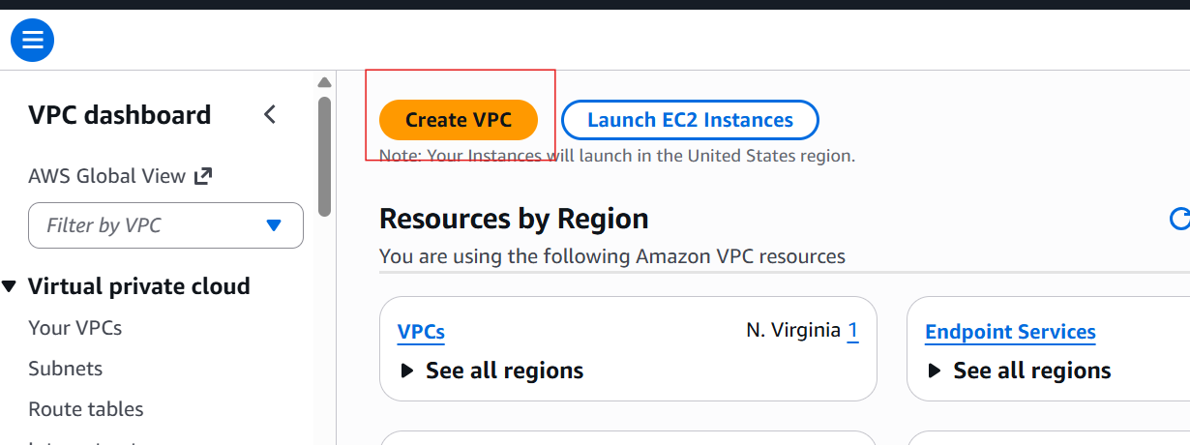
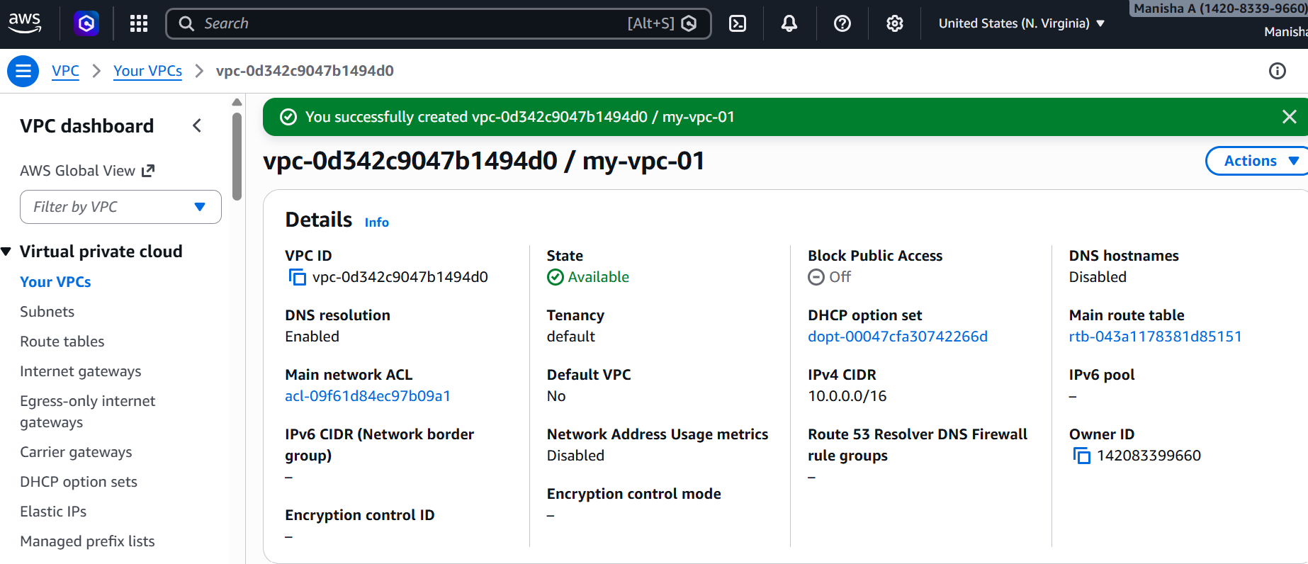
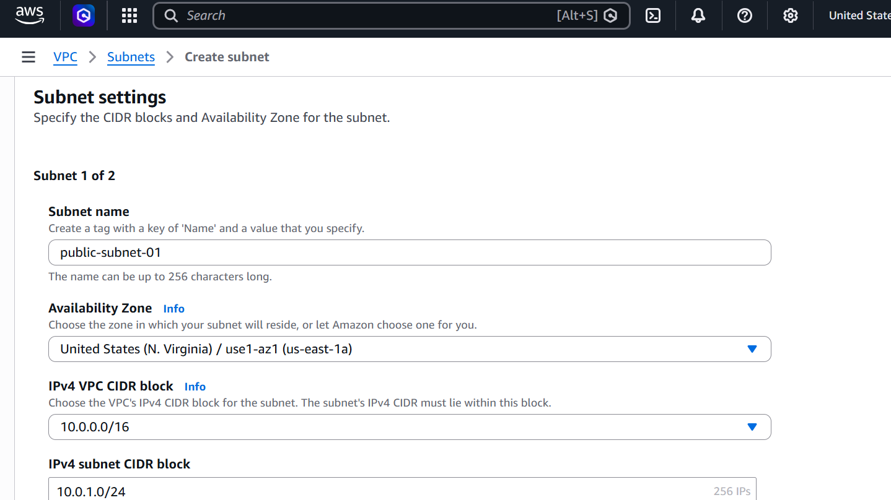
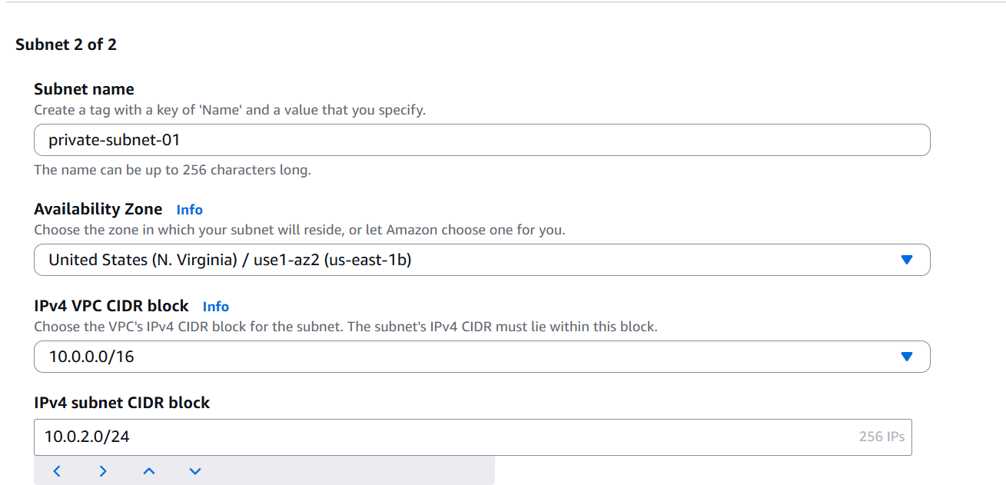
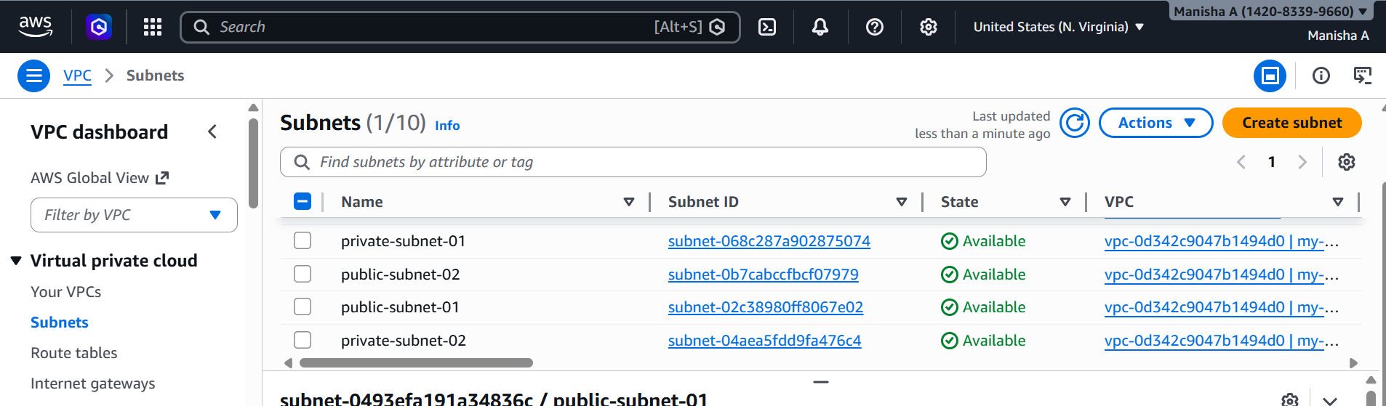
2.Enable DNS Hostname in VPC.
-> Go to VPC Dashboard
-> Click on Your VPCs
->Select your VPC
->Click on Actions
->Select Edit VPC settings
->Enable DNS hostnames
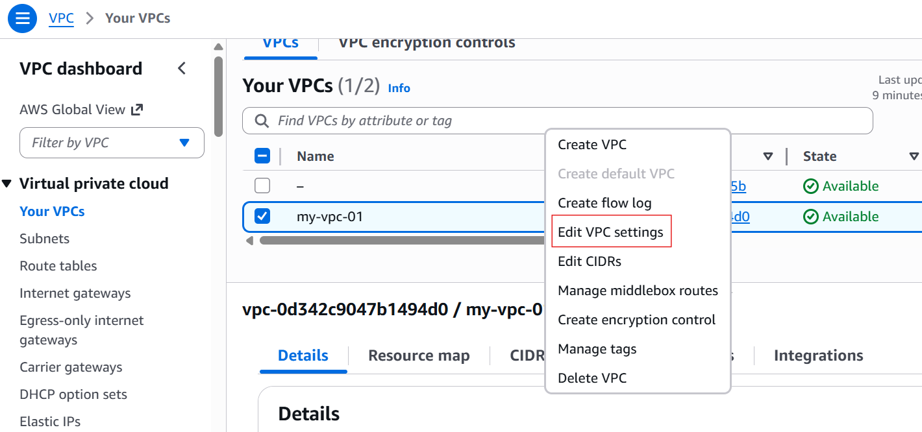
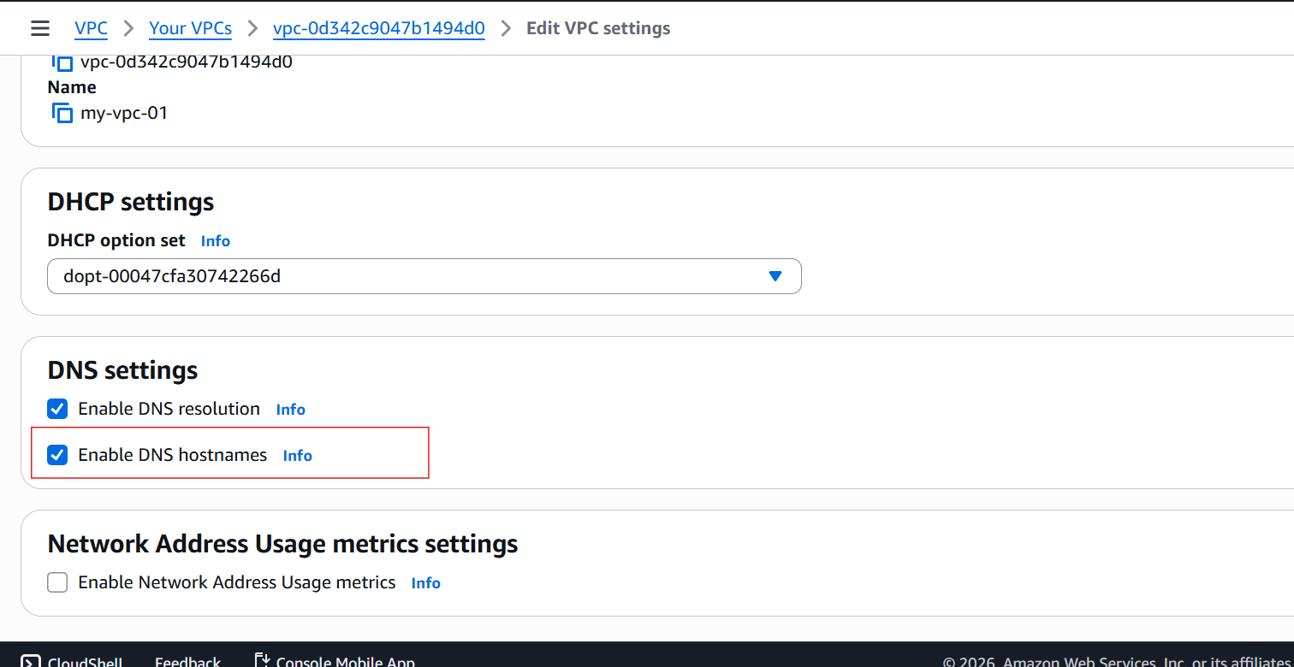
3. Enable Auto Assign Public IP in 2 public subnets.
-> Go to public subnet
-> Click on edit subnet settings
->Enable auto assign public ip for both the subnets
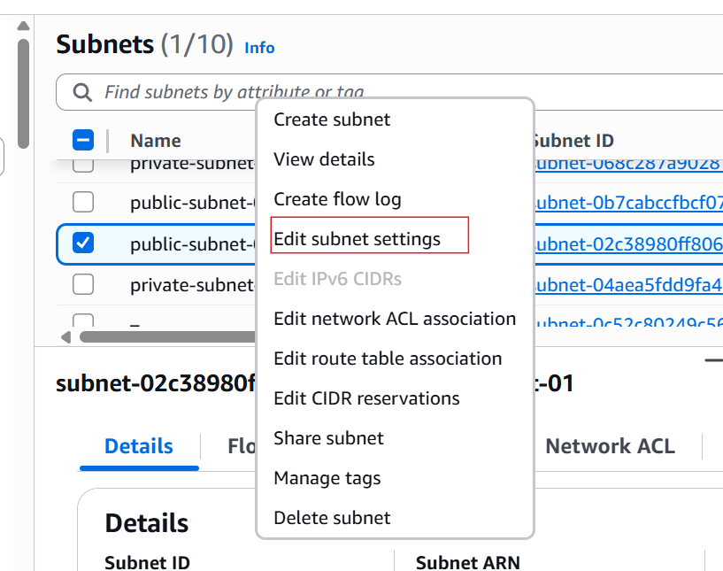
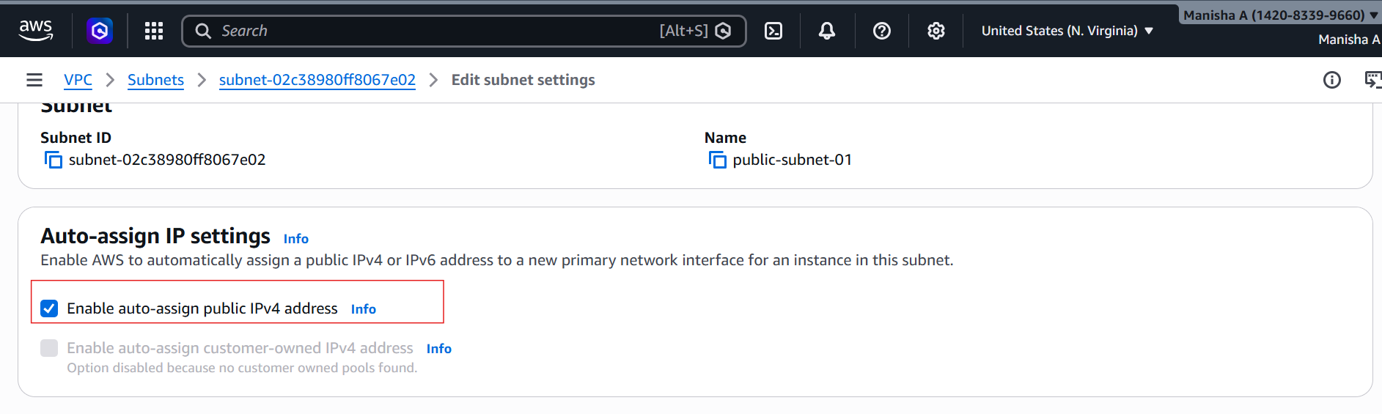
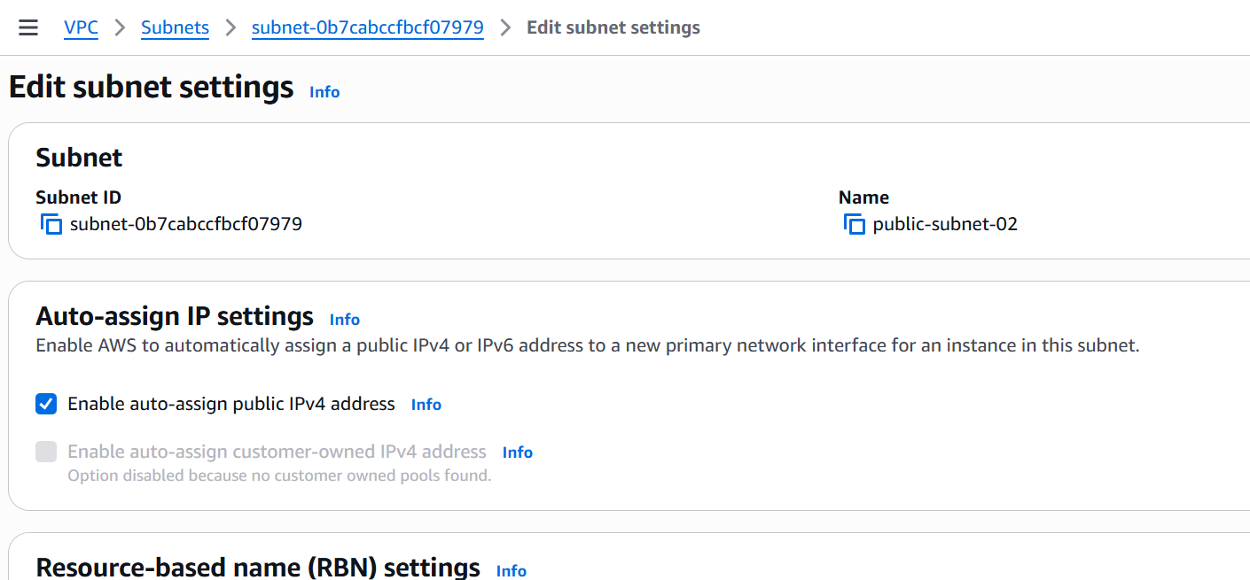
4. Add 2 private subnets in private route table.
->First created a private route table
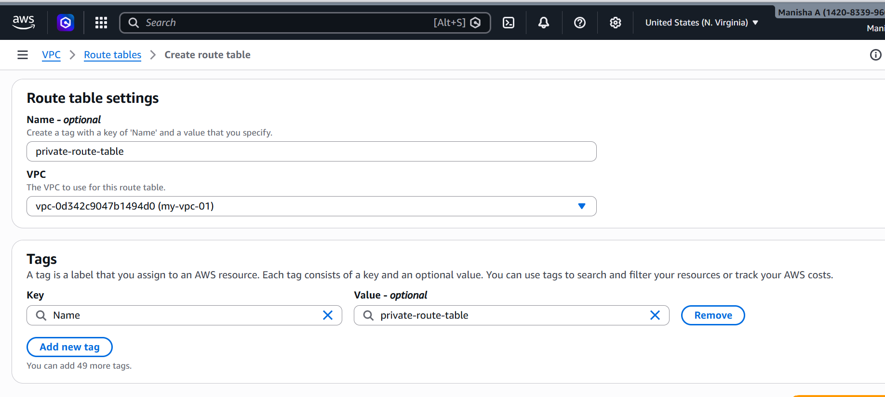
- Edited subnet assosiations by adding two private subnets
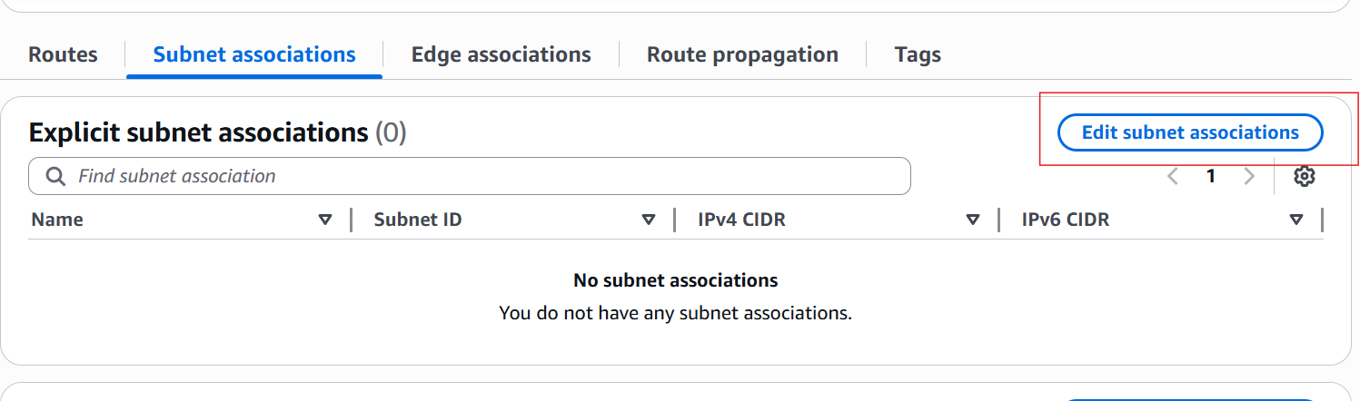
- Saved the associations
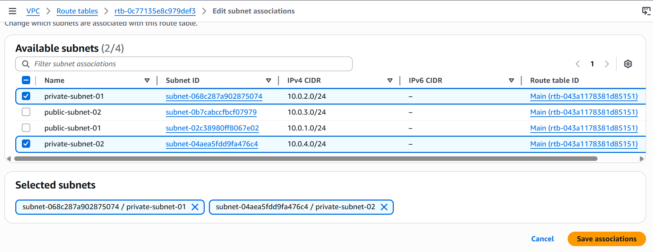
- Checked whether they are added
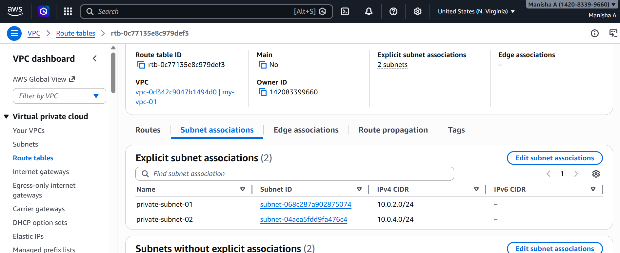

5. Add 2 public subnets in public route table.
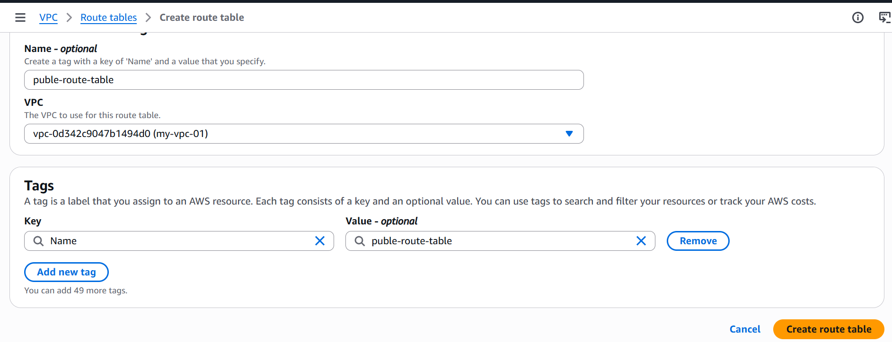
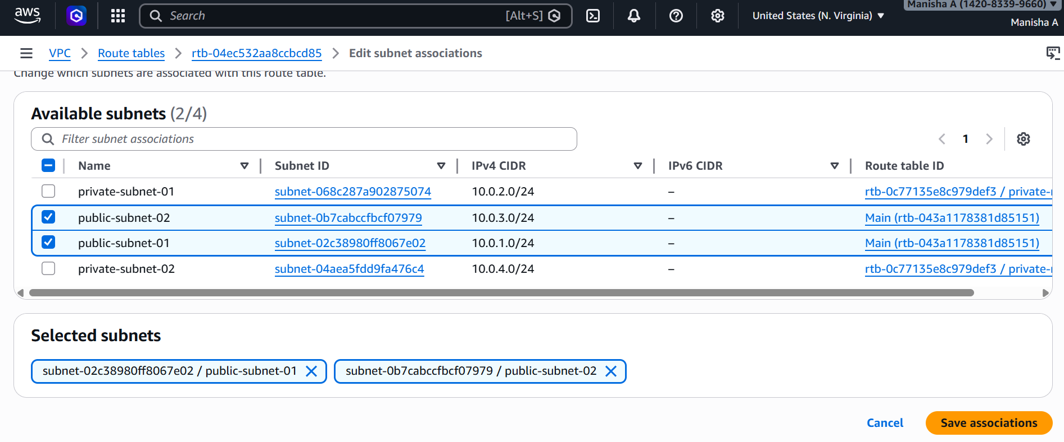
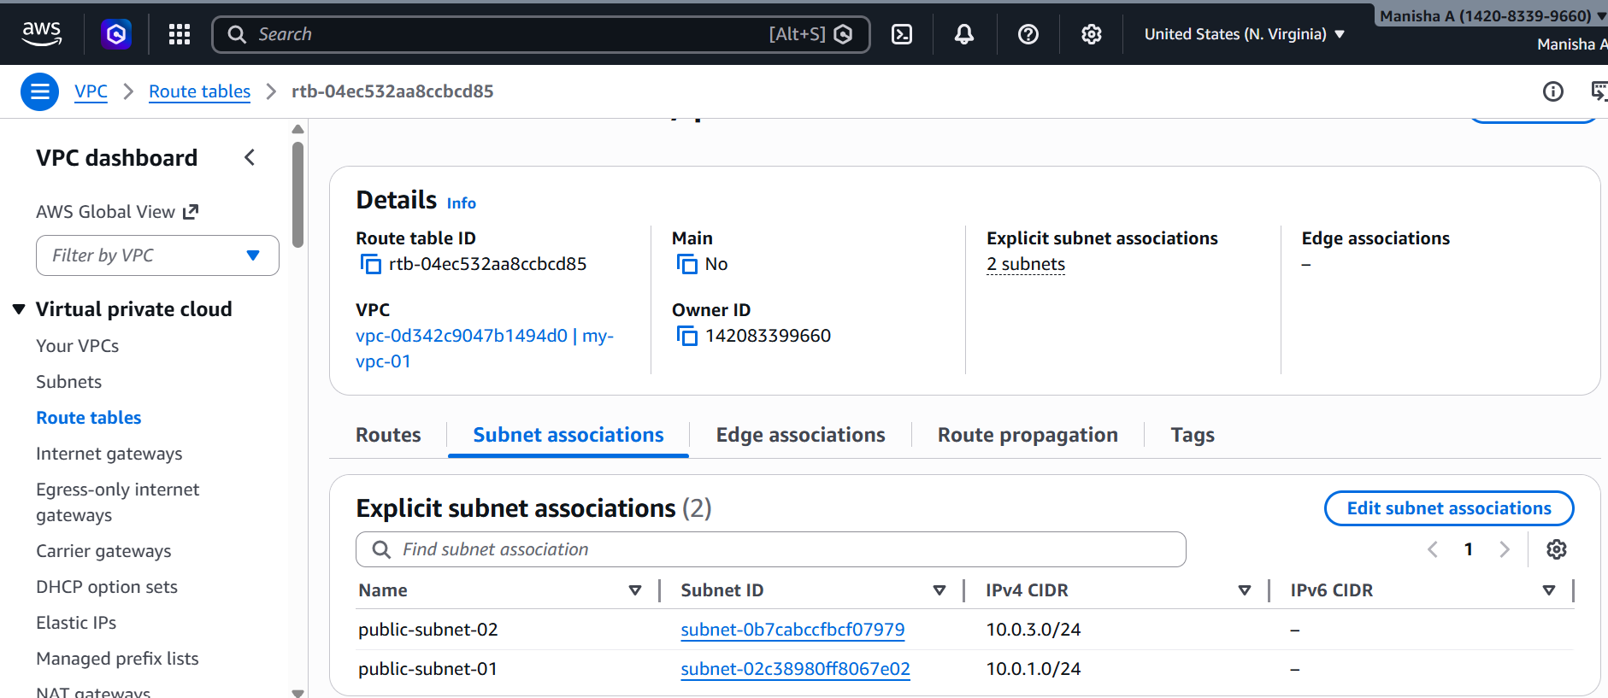
6. Public route table will have the routes to internet and local.
-> I have created a internet gateway
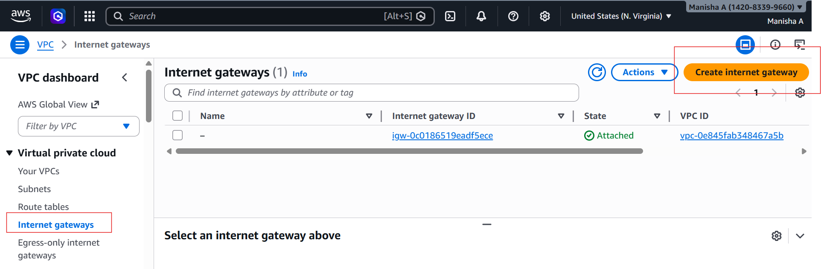
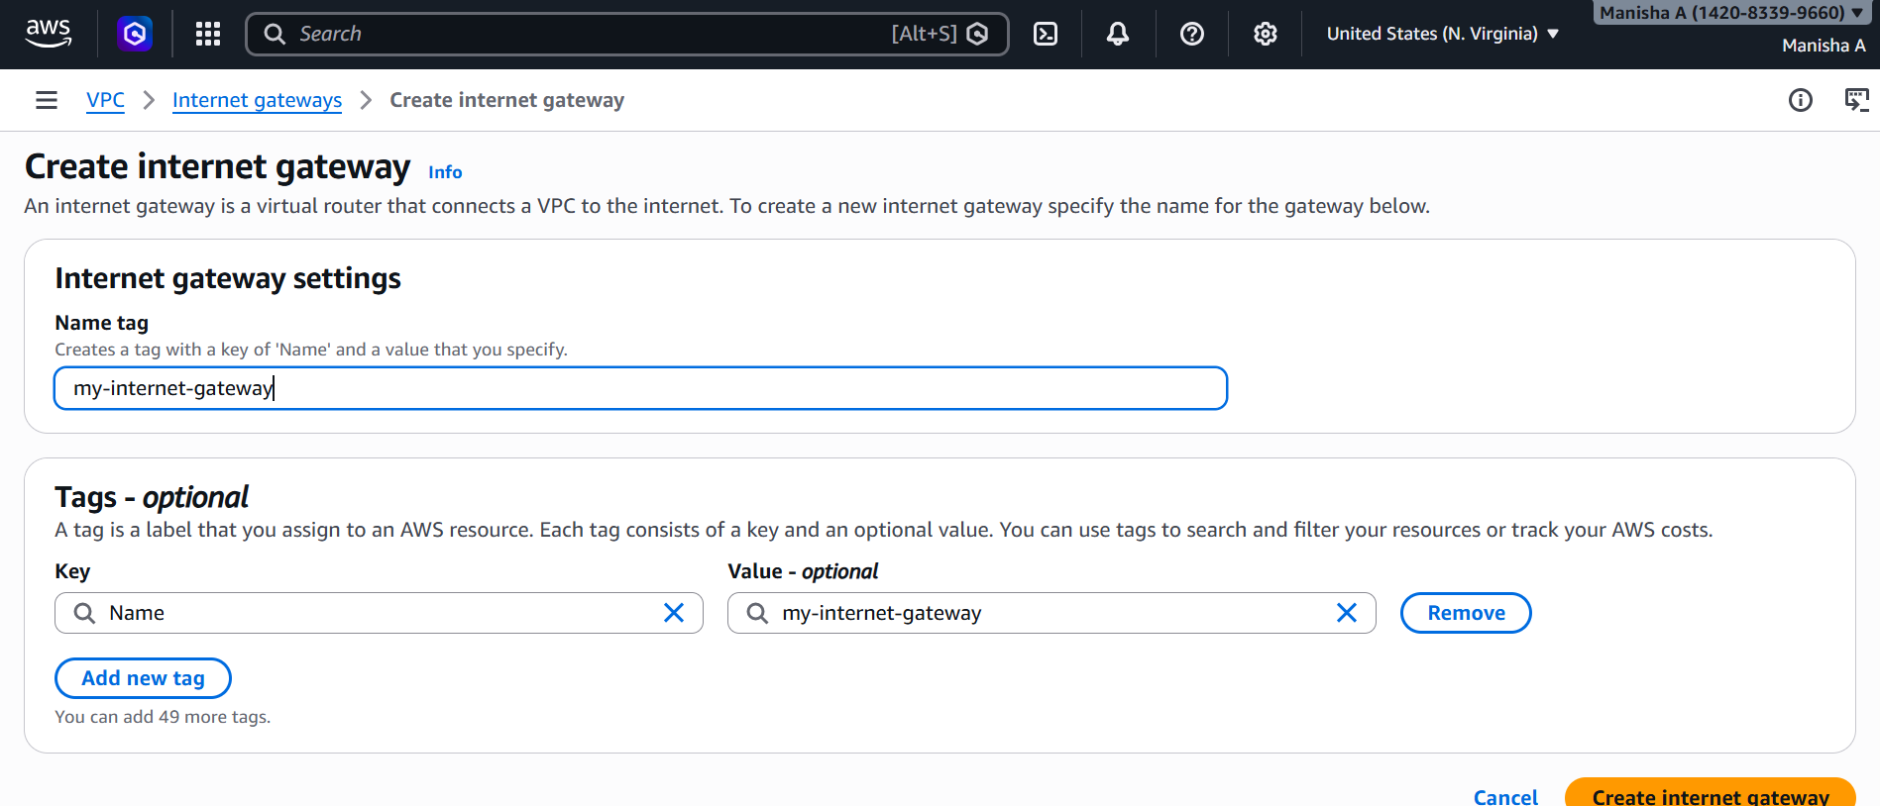
- Attached internet gateway to VPC

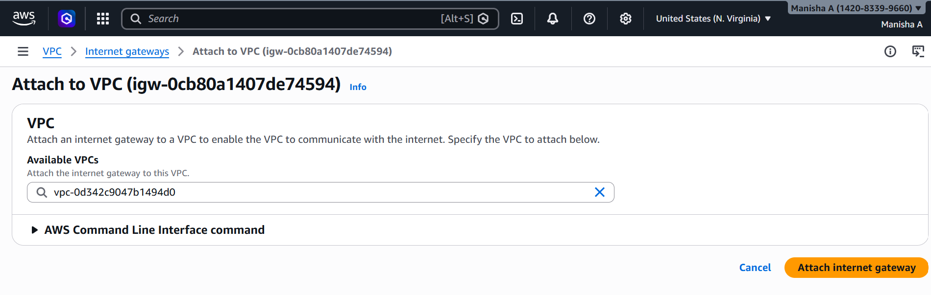
- I have added routes by selecting edit route and saved changes
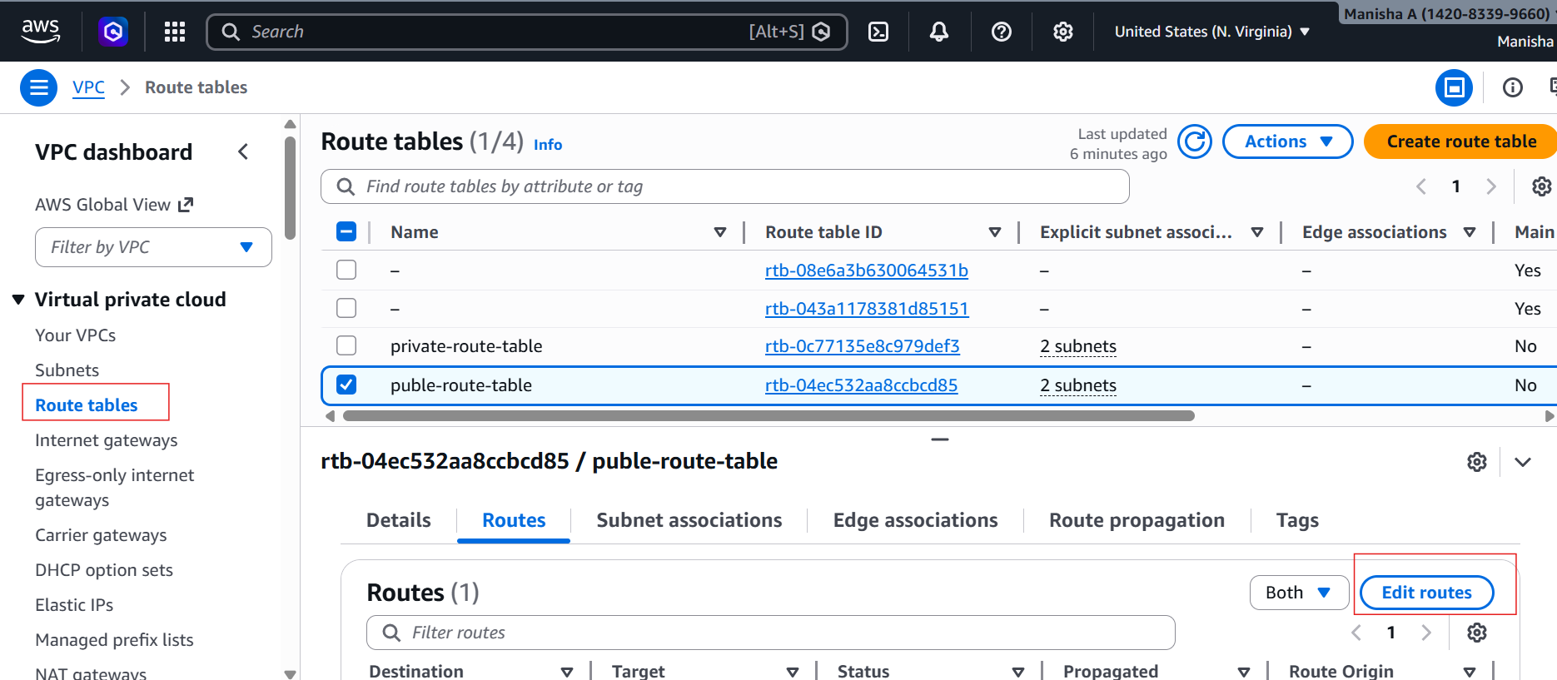
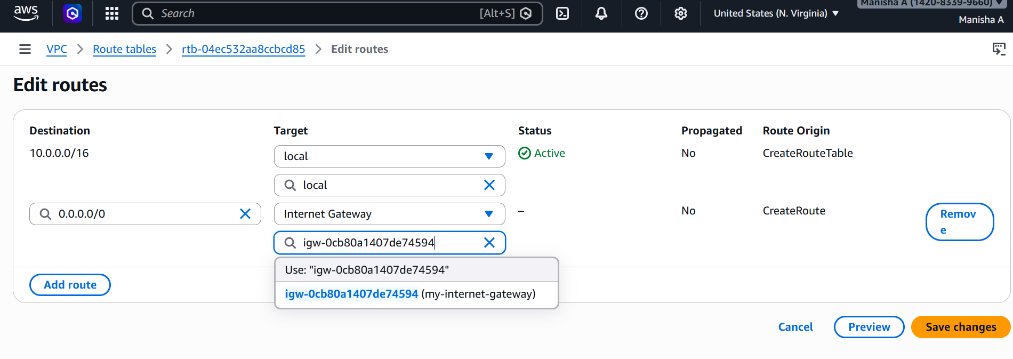
- Viewed the route table
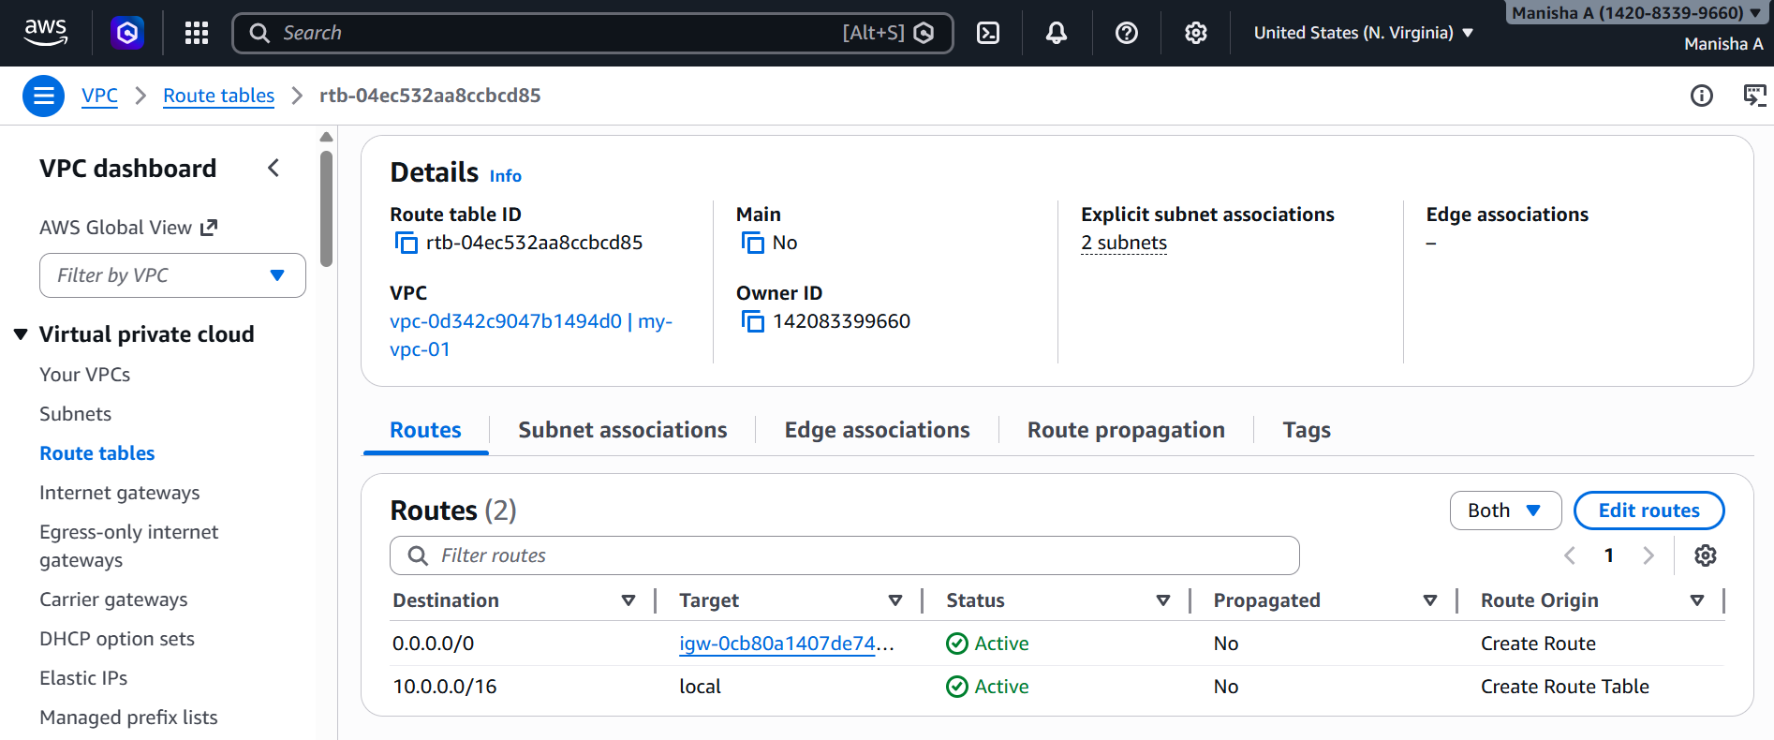
7.Create EC2 in public subnet with t2.micro and install PHP.
-> Launched a new instance
-Under Network Settings:
- VPC: Select your VPC (MyVPC)
- Subnet: Select public-subnet-02
- Enable Auto-assign Public IP

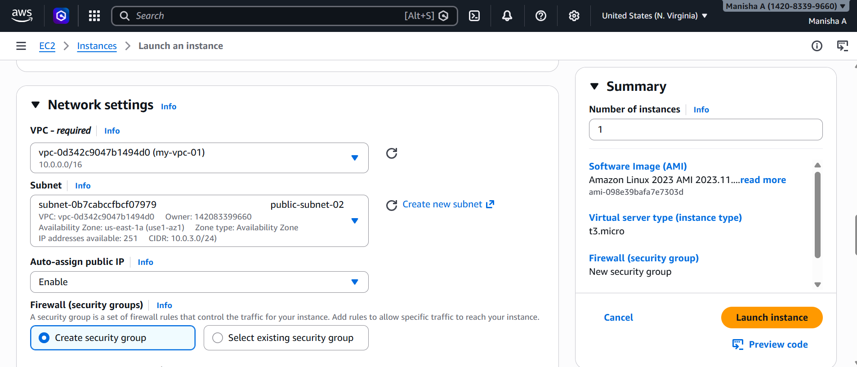
- I have connected EC2
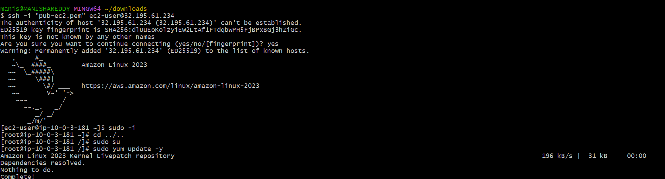
- Installed PHP with the below commands
- sudo yum update -y
- sudo yum install php
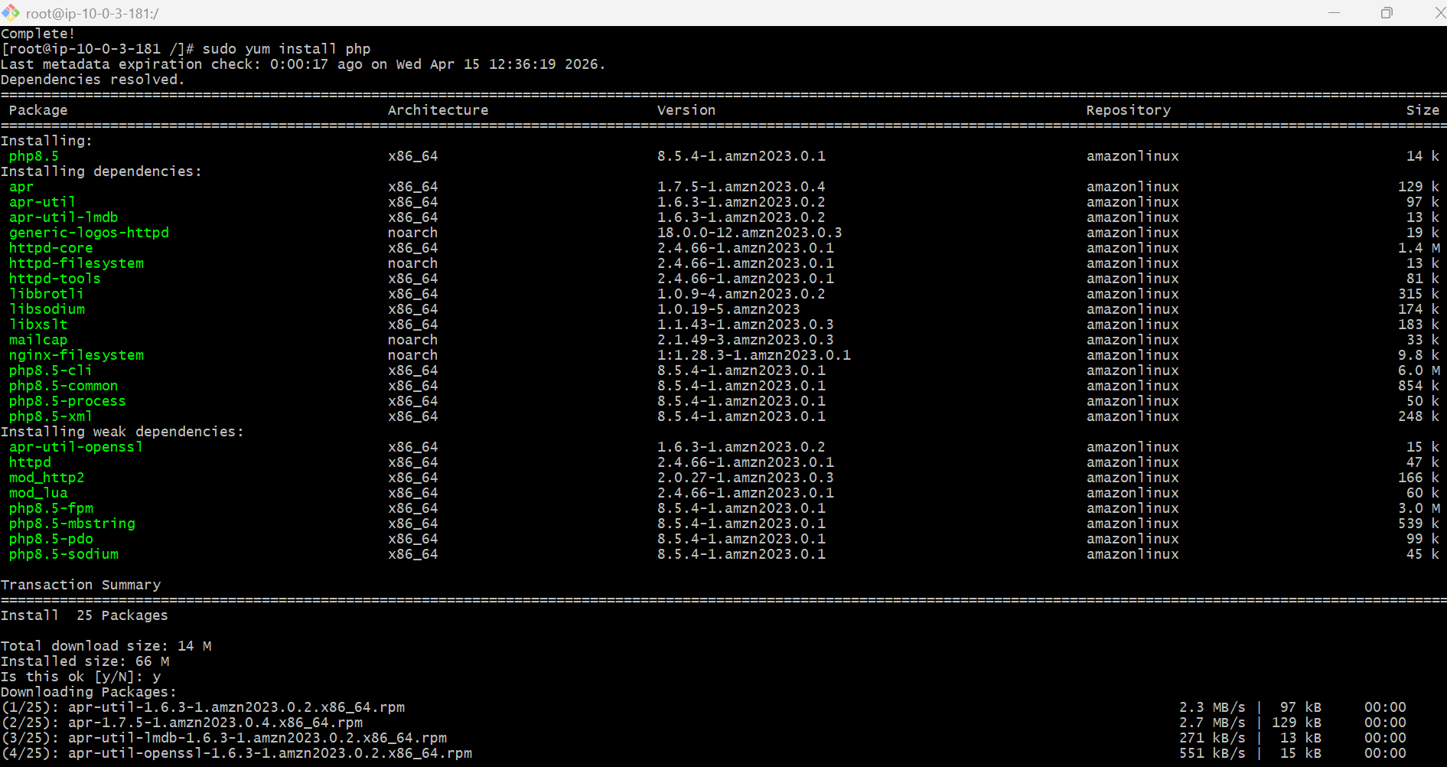
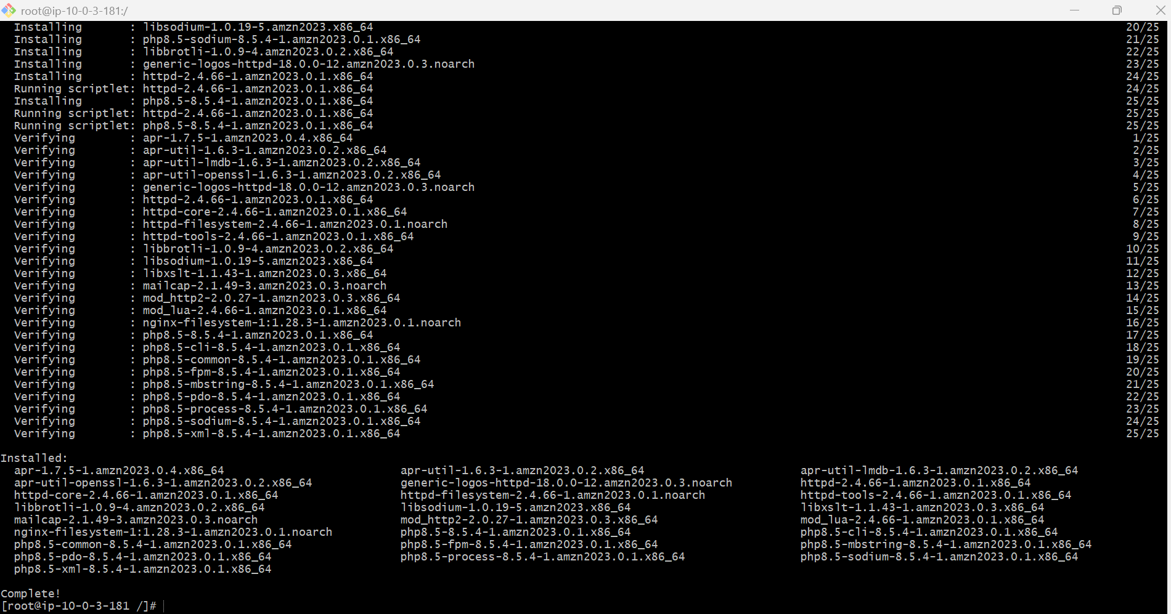
8. Configure NAT gateway in public subnet and connect to private instance.
-> Create NAT gateway
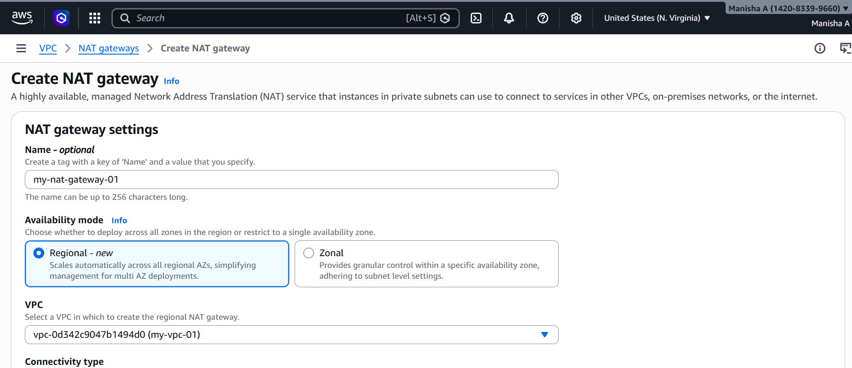
-Update Private Route Table
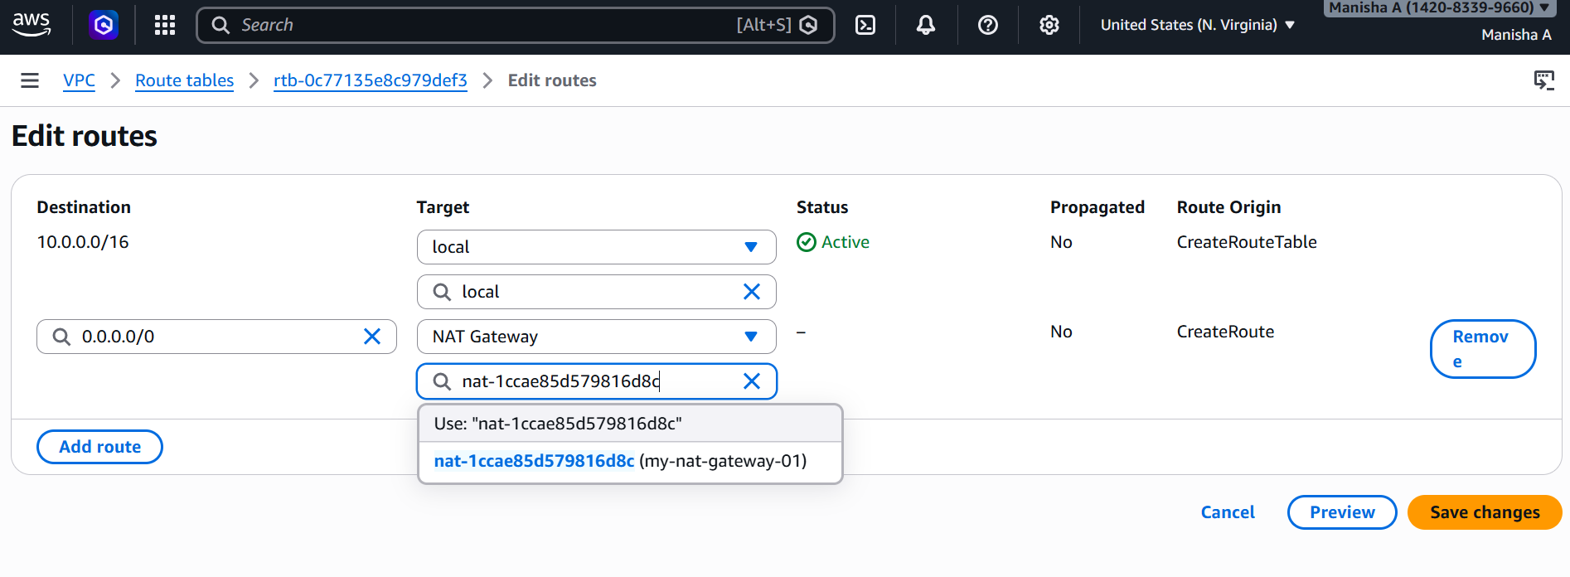
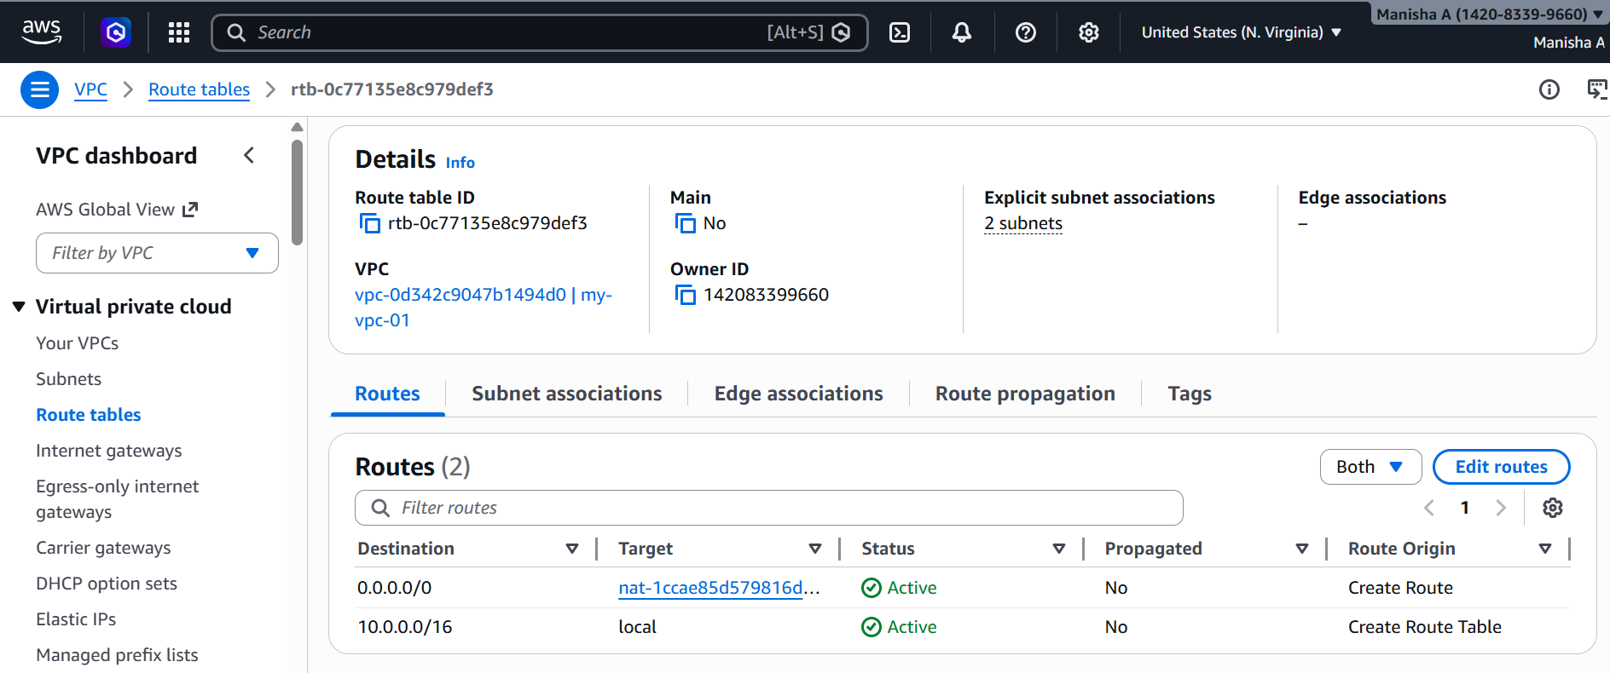
Created a private instance
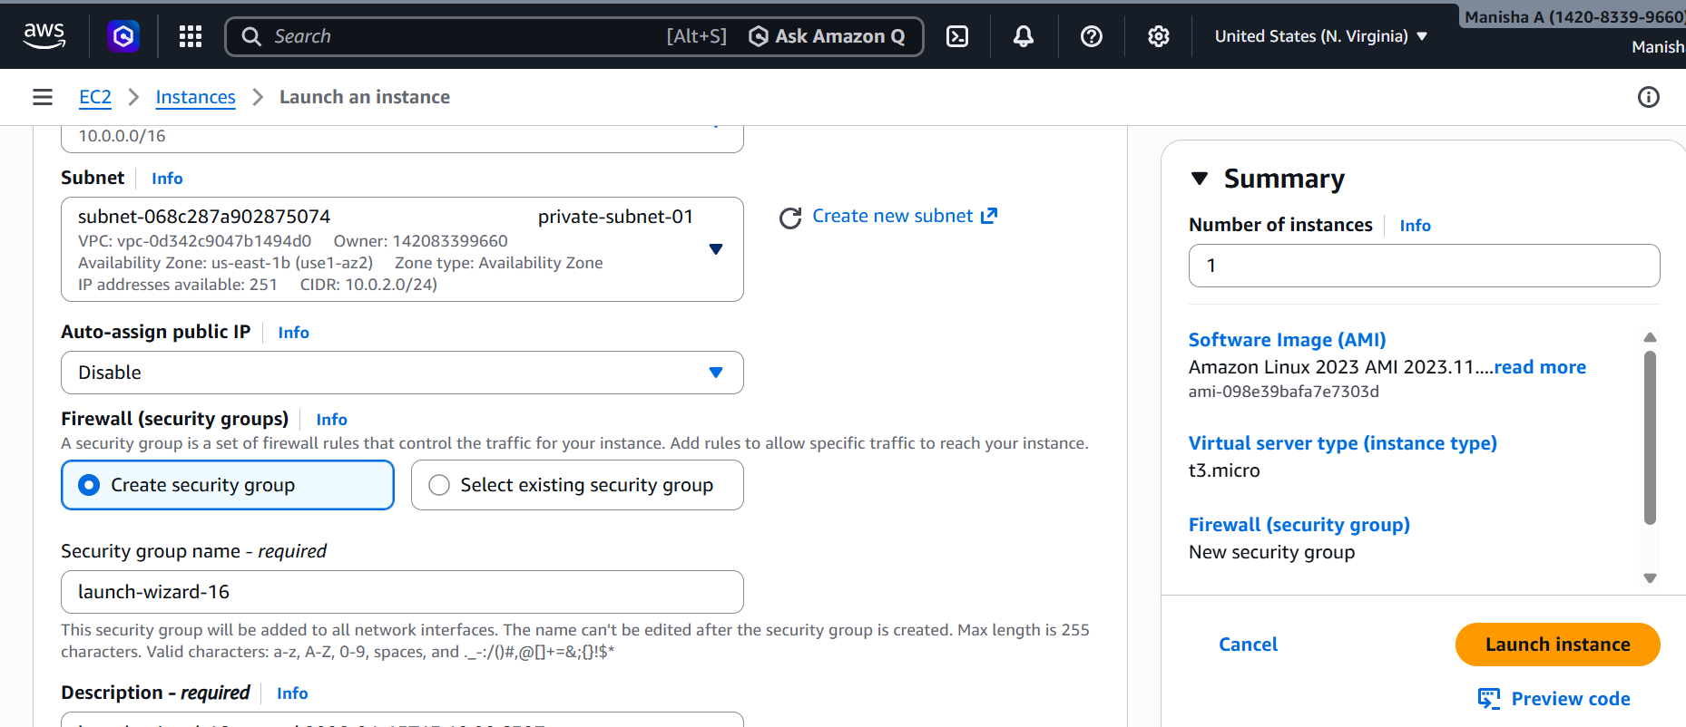
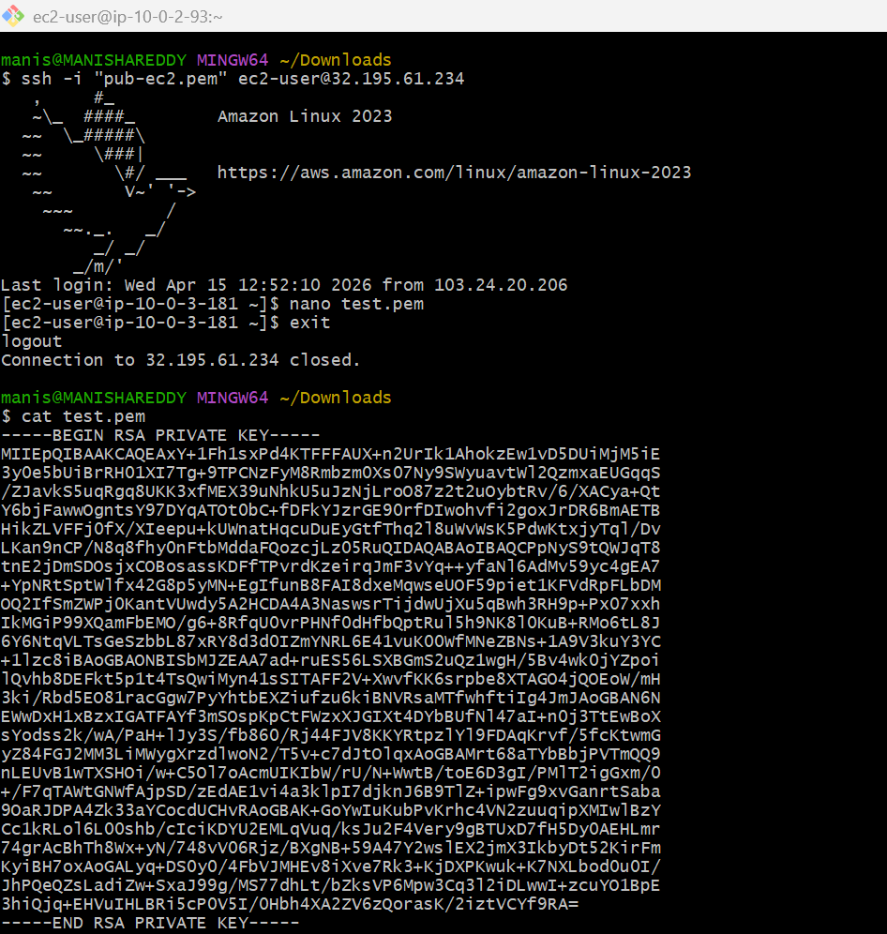
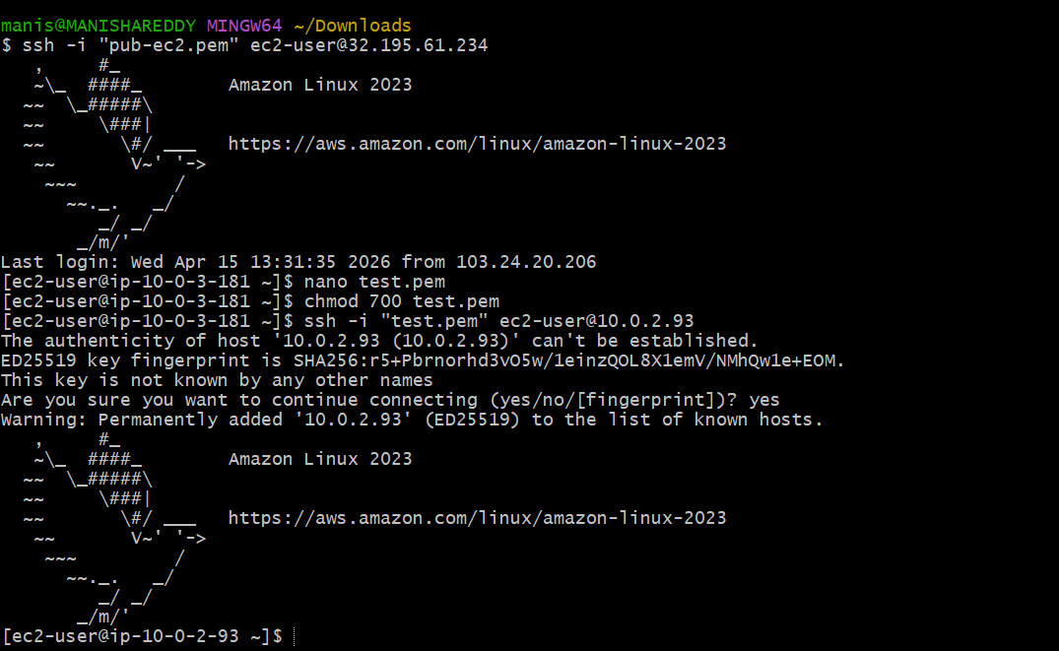
9.Install Apache Tomcat in private EC2 and deploy a sample app.

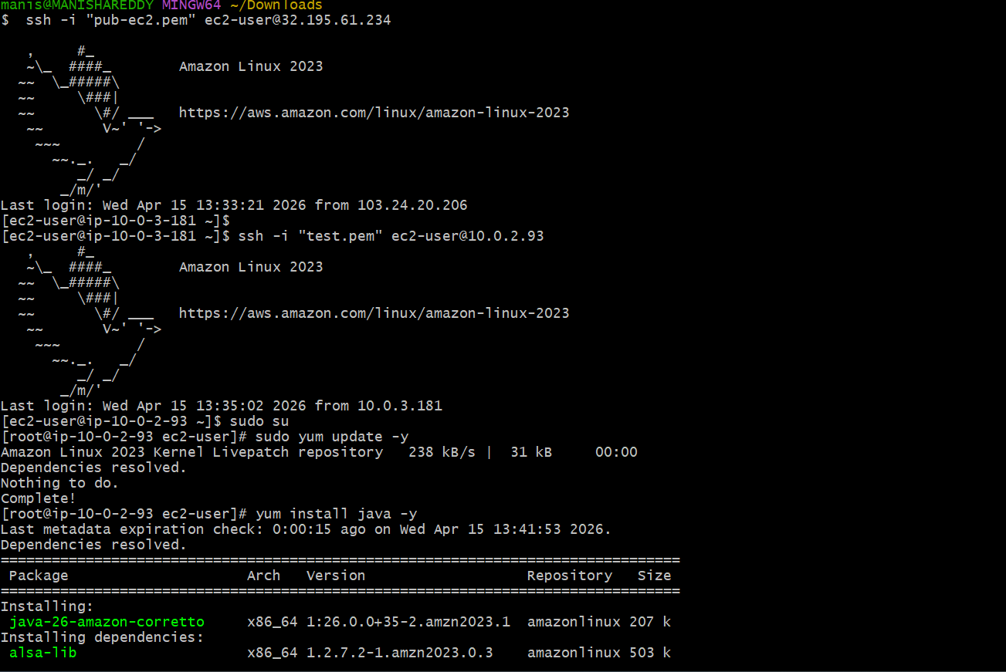
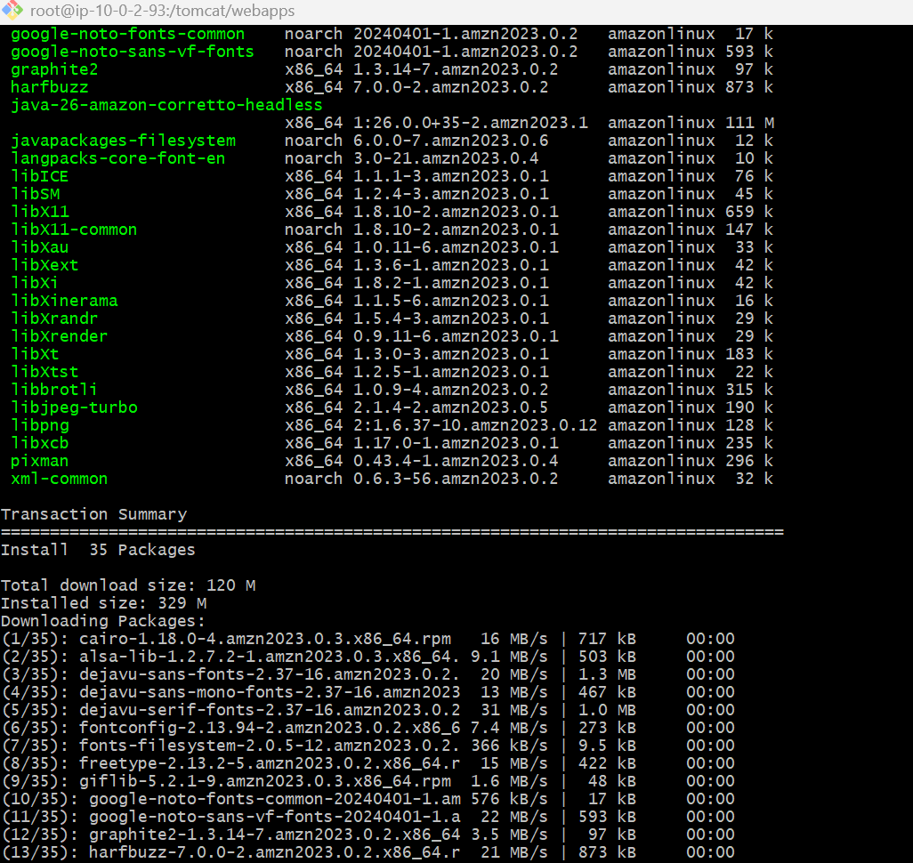
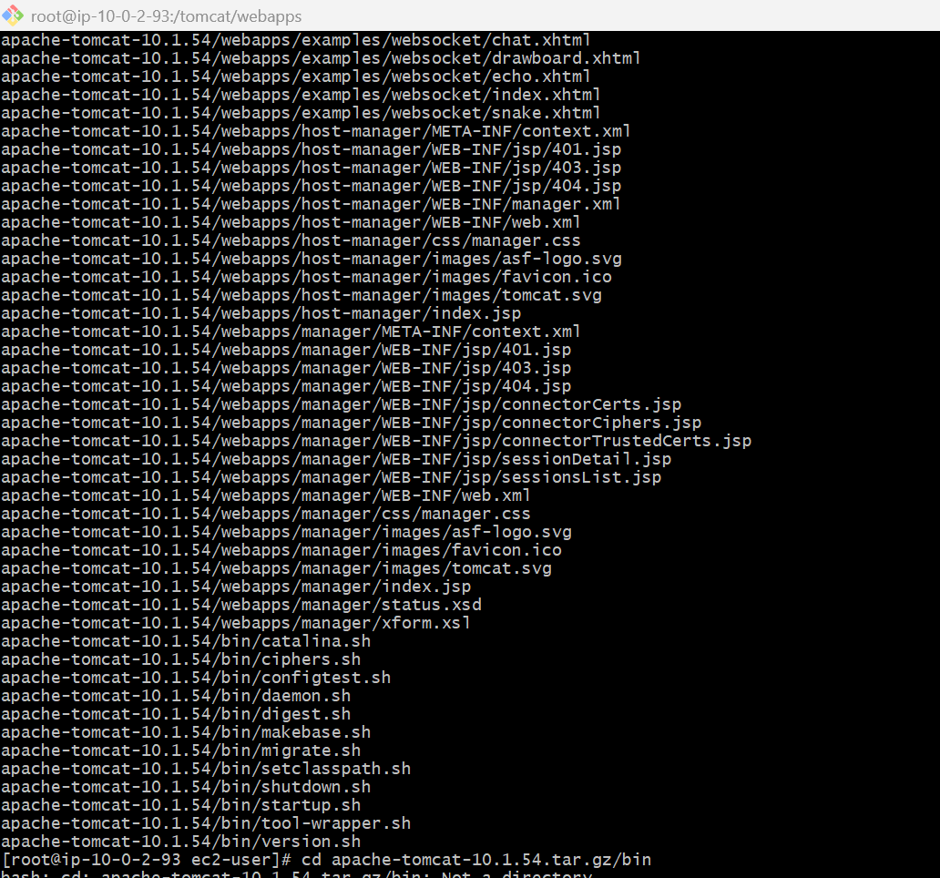
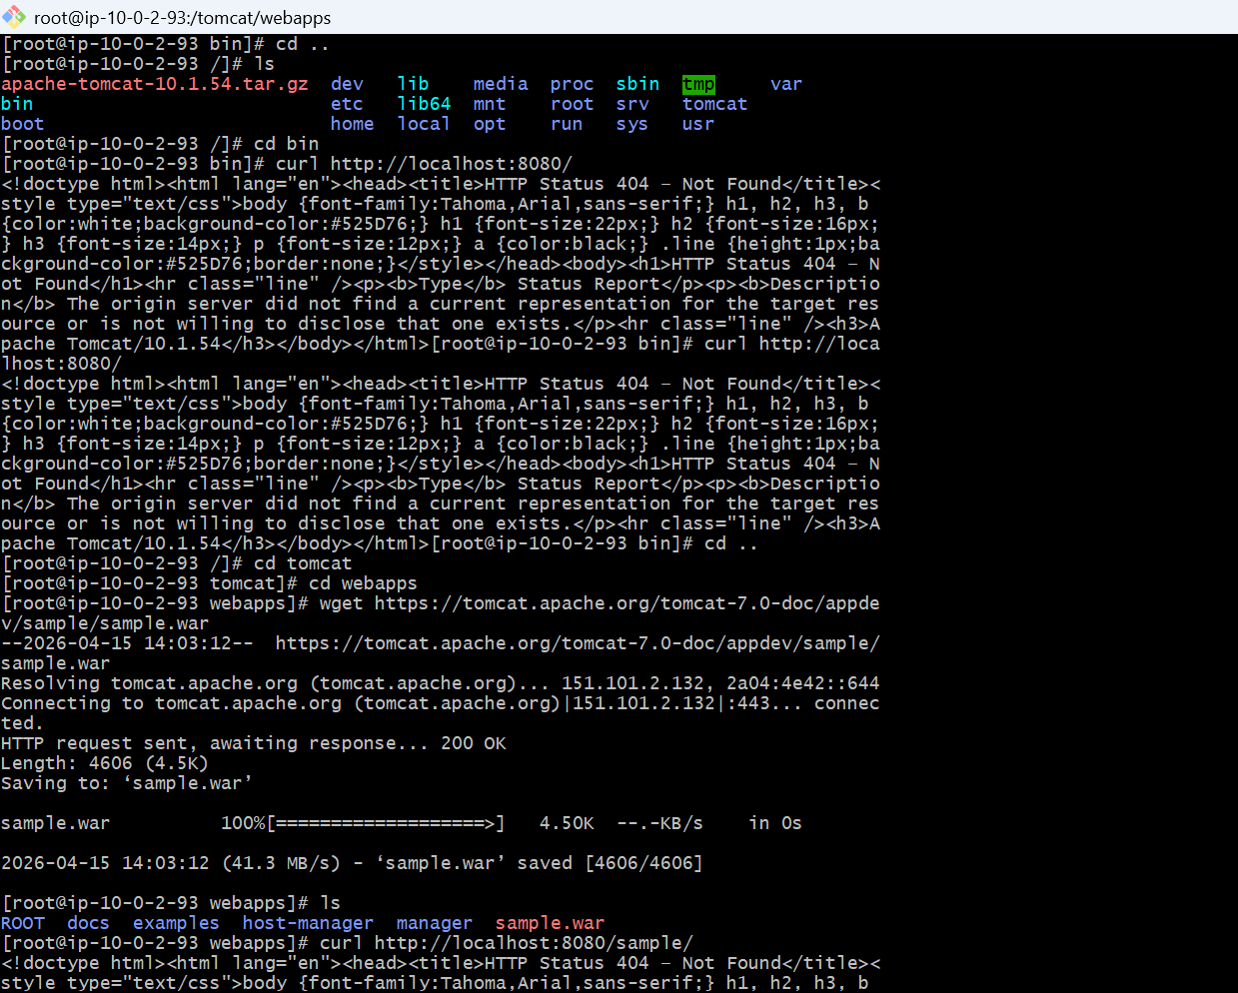
10. Configure VPC flow logs and store the logs in S3 and CloudWatch.
->Create S3 Bucket (for logs)
->Create Flow Logs for VPC
->Create Flow Logs for S3
